

THE UNIVERSITY OF AZAD JAMMU AND KASHMIR, MUZAFFARABAD.

DEPARTMENT OF SOFTWARE ENGINEERING
Task No 2

Submitted to: | Engr. Sidra Rafique
Submitted by: | Faheem Rasool
Roll no: | 2023-SE-17
Session: | 2023-2027
Subject: | HCL
Semester: | 6th

1. Target Application: A Budgeting and Financial Planner App (e.g., "CoinTracker")

1. Target Application: A Budgeting and Financial Planner App (e.g., "CoinTracker")
Target Application Description: This application is designed to help users manage their daily finances, track spending, set savings goals, and view their overall financial health. The app targets a wide demographic, including young adults just starting to manage their money and experienced budgeters.

2. UI Improvement Analysis
I have identified three common UI issues on login/registration pages for financial applications and designed a solution that addresses them, as visualized in the generated image below.
BEFORE AFTER

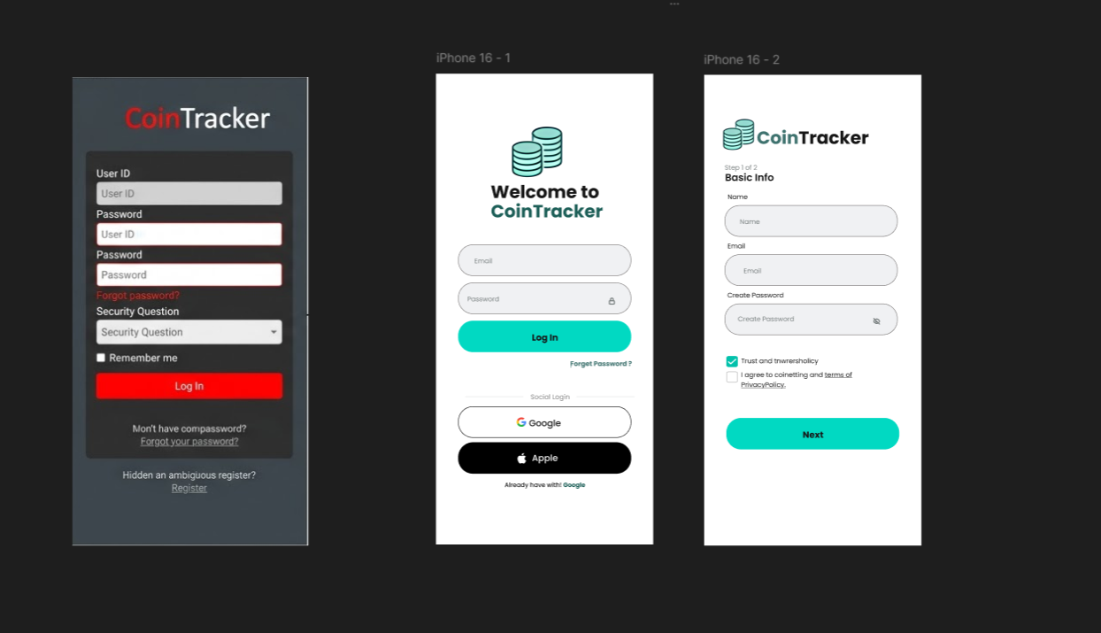

Image Description: High-Fidelity UI Comparison (Conceptual)
The generated image simulates a Figma workspace. The (BEFORE) illustrates a flawed design, while the (AFTER) visualizes the improved, modern design you should aim to create for the "CoinTracker" app.

How the Design Addresses Existing Issues (Referencing the Image)

Issue 1: Cluttered Layout and Cognitive Overload (See 'BEFORE')
- Problem: Existing financial apps often require too much information upfront (User ID, specific security questions), which can be intimidating and discourage registration.
- Improvement (The 'AFTER' Design): My design simplifies the login to only 'Email' and 'Password'. For registration, it uses a "Step 1 of 2" (Multi-step form) approach. This minimizes the fields shown at once, making the process feel less overwhelming.

Issue 2: Poor Visual Hierarchy and Hidden Actions (See 'BEFORE')
- Problem: In the old design, the primary action button ("Register") is often buried or lacks contrast, making it hard to find. Social login options (Google/Apple) are frequently missing.
- Improvement (The 'AFTER' Design): The main "Log In" and "Next" buttons utilize a high-contrast teal color. Key navigation like "Forgot Password?" or the "Login" toggle on the registration screen is placed logically and styled clearly. Social logins are prominent, allowing for a frictionless one-tap experience.

Issue 3: Lacking Trust and Modern Aesthetic (See 'BEFORE')
- Problem: Dark, harsh color palettes and sharp, dated design elements in finance apps can feel intimidating, decreasing user trust.
- Improvement (The 'AFTER' Design): The design utilizes a light, clean interface with soft background colors (light teal) and generous padding (white space). The use of modern iconography and a clean, coin-stack logo helps establish professional credibility and instills confidence in the user.
__________________________________________________________________________THE END

